Place Value Word Problems Answer Sheet
Problem #1:
Brad is preparing to make goody bags for her after school program. She needs to make seven goody bags since there are seven students involved in her after school program. She wants to include three pieces of candy in each bag. How many pieces of candy will she need?
Goody bag 1:
Goody bag 2:
Goody bag 3:
Goody bag 4:
Goody bag 5:
Goody bag 6:
Goody bag 7:

Answer: Brad will need 21 pieces of candy to make seven goody bag.
Problem #2:
Isabella has 3 hundreds, 5 tens, and 6 ones. How many ones would this be?

3 hundreds: 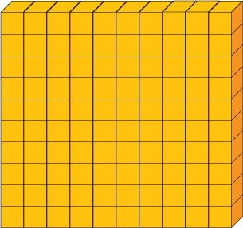
5 tens:

6 ones: 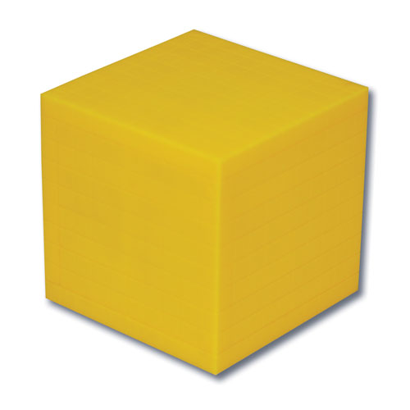

Answer: Isabella has 356 ones
Problem #3:
Lindsey needs help with counting all the students in the recess yard. She decides to put 100 students into one group, 60 students into groups of ten, and 3 students in their individual groups. How many students were in the recess yard in total?

100 students into one group:

60 students into groups of ten:

3 students in their individual groups:

Answer: There are 163 students total in the recess yard.

